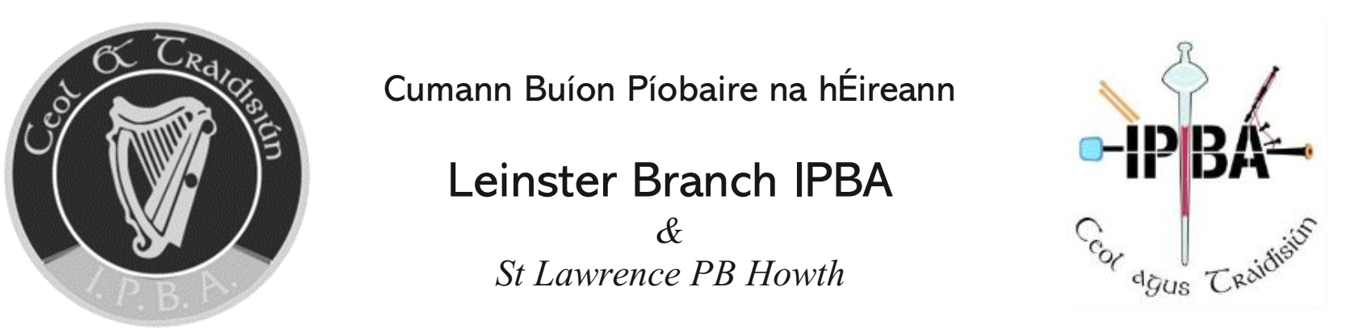

|  |  |  |  |  |  |
| --- | --- | --- | --- | --- | --- |
| East of Ireland Pipe Band Championships 2024 | | | | | |
|  |  | | | | |
| Band |  | | | | |
|  |  | | | | |
| Grade (s) |  | Tartan | |  | |
|  |  | | | | |
| Pipe Major |  | | | | |
|  |  | | | | |
| Lead Drummer |  | | | | |
|  |  | | | | |
|  |  | | | | |
|  |  | | | | |
| Selection |  | | | | |
|  |  | | | | |
|  |  | | | | |
|  |  | | | | |
|  |  | | | | |
| Drum Major |  | | Grade | |  |

* Closing Date for Entry: Friday 21st June 2024